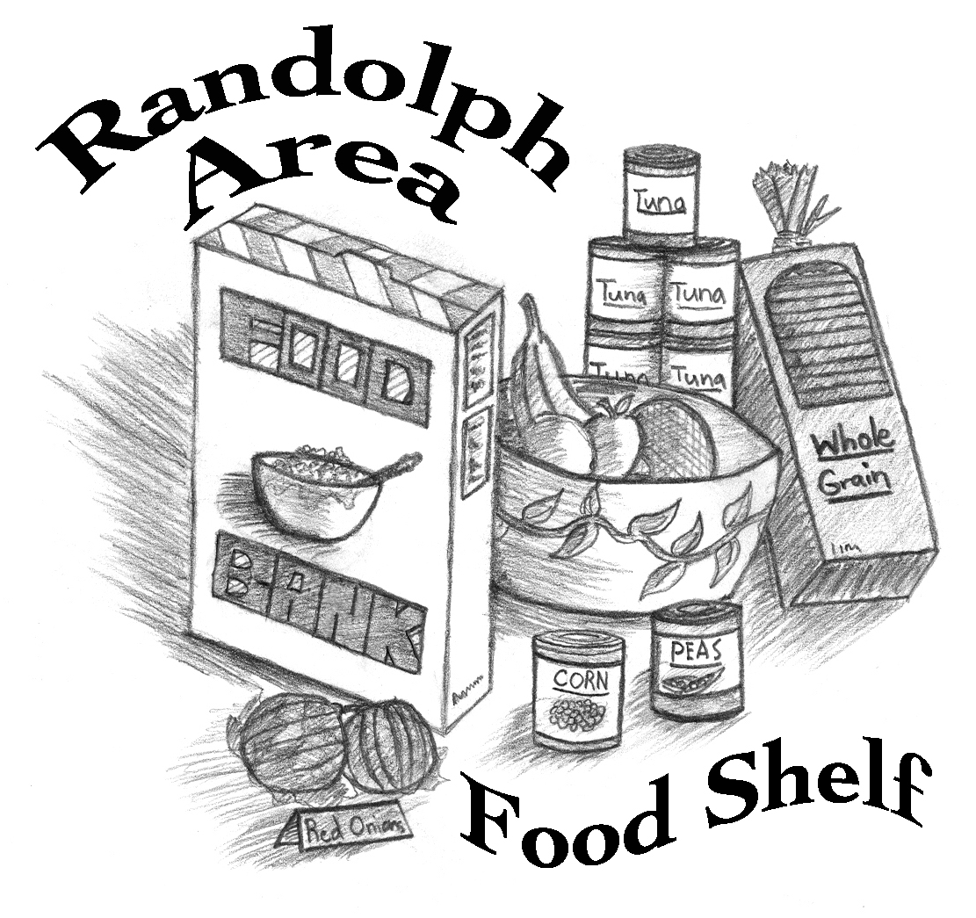

Board of Trustees Procedure Manual

Title: Receiving and Categorizing Food

Date Adopted: January 9, 2017 – revised 11/22/19

Foods Received and Days Delivered

The Randolph Area Food Shelf receives food from several different sources. Some food is donated and some is purchased. The Vermont Foodbank is the main source for our food, and non-food, supplies. As of November 2019, the major sources of products offered come from the following sources:

- Donated foods received from the Foodbank (some free and some at a cost) are delivered on the third Friday of the month. Additional mid-month food orders are picked up at the Foodbank by volunteers and delivered to the Food Shelf.
- Pastries, breads, frozen meat and other frozen items donated by Shaw’s in Randolph are picked up by a Food Shelf volunteer on Monday and Wednesday mornings.
- Donated goods are picked up from the Randolph Cumberland Farms three days per week, Monday, Wednesday and Friday.
- Milk is purchased from Sprague’s Dairy. They deliver on Mondays and Thursdays and place the milk in the cooler.
- Eggs are purchased from several sources and are delivered weekly but not on a set schedule except that eggs from Maple Meadow are delivered on Thursday mornings.
- Some fresh produce is purchased locally, in season and some is purchased commercially.
- Household products – toilet paper and laundry detergent – are purchased commercially as are health and beauty supplies that include shampoo, soap, toothbrushes and toothpaste.
- Individual donations may be delivered at any time. Food drive deliveries need to be coordinated in advance with Pantry Operations.

Receiving Procedures – Foodbank Deliveries

- Separate frozen foods and put them in the freezers located in the warehouse.
- Separate refrigerated items and place in the refrigerators in the warehouse.
- Using the packing slip from the Foodbank, separate the items ordered for the USDA Commodities program. Remove the plastic wrapping and write the month the commodities are for (usually the month following the actual delivery) and year on the cardboard tray. Place them in the warehouse area marked for USDA. Move the older foods and group them together so the newly arrived foods are separated from the older foods.
- Using the packing slip from the Foodbank, identify the case items the Randolph Area Food Shelf has paid for and check to see that the correct numbers have been delivered. These do not have to have the plastic wrapping removed. Place on the shelves as labeled (e.g. canned vegetables, peanut butter).
- The large “banana boxes” contain reclaimed foods that the Randolph Area Food Shelf did not have to pay for. These boxes are usually put on pallets in the center of the storeroom. They have to be emptied and sorted, and the products placed on the appropriate areas in the storeroom (shelves are marked). Before placing them on the shelves, the canned foods are dated (using a marker write the best by/use by/sell by -which ever is found on the can – on the top of the can. If the cans are going to be put on shelves in the storeroom they should be arranged on cardboard trays. If there isn't enough room on the storeroom shelves, the cans that have been dated can be returned to the banana box and stored on a shelf or pallet in the warehouse. Be sure to label the box with the category of food and the date it was put in the warehouse. See Canned Food Procedures below for details.

Receiving Procedures – Eggs

If eggs are received when the Food Shelf is open, volunteers are asked to fill in the chart on the warehouse refrigerator door to indicate how many dozen were received on the day received. This is done so a proper inventory can be taken and orders can be adjusted accordingly. If the eggs are donations, the volunteer also records the donation on the record form.

Receiving Procedures – Canned Goods

- All food items not received as case lots need to be checked for date codes. The month and year of expiration should be written on the top of cans in black marker.

- The only exceptions to the date coding are case lots, trays wrapped in plastic, which we receive from the Foodbank, such as peanut butter, tuna, or macaroni and cheese. Foods that come in sealed boxes (e.g. jelly) also do not need to be date coded. We go through these items so fast that they don't expire, so there is no need to code them.

- Reclaim cans from the Foodbank and donated cans must be evaluated for suitability. Dented cans may be used unless:
  - the dents make it impossible to open
  - the dent has created a hole, puncture, or has damaged a seam
  - the label has come off
  - the can is rusted, bulging, or leaking

Quality control – Appearance or condition of food

- Any bulging or badly rusted cans must be discarded regardless of the date.
- Any item that is leaking must be thrown out.
- All unsafe cans go into the box in the storeroom labeled for them.
- All out-dated fresh food or spoiled food such as bread, goes into boxes in the "Pig Food" area in the warehouse near the garage doors.
- Spoiled vegetables and fruits go into the pig food buckets in the warehouse by the garage door. Be sure there is a plastic bag lining the bucket before putting food in it. Do not put any meat products, or wrapped, or packaged items in these buckets.
- Spoiled meat products should be put in a plastic bag tied with orange reflective tape and placed in a freezer in the warehouse.

Food Categories

Generally, foods are grouped by category and placed on the shelf in the area set aside for that category without regard to package size. Aseptic cartons are treated like canned food. These categories match the shopping list that tells a client the amount of food allocated based on family size.

Home Canned or Baked Goods

These items must be labeled so they tell who produced the item, the date
it was produced and all of the ingredients. They are placed on the shelves with other foods of the same category.

Very Large Products

Some products, like dog and cat food, come in large packages and should be broken down into smaller amounts. Other items that are usually divided into smaller packages include cheese in large wheels, boxes of single-serve items, large watermelons or similar produce. There are supplies of plastic bags and plastic wrap to help with this. Volunteers need to use their best judgment to determine what size to make but should keep in mind what amount would be equivalent to the weight/size of other products in the same category.

Food Categories

1. Canned Soup
2. Dried soup
3. Canned Vegetables
4. Pasta (Plain noodles, spaghetti, and other pasta shapes)
5. Rice (Plain white and brown rice)
6. Boxed Macaroni & cheese
7. Spaghetti Sauce
8. Canned tuna or canned chicken
9. Beans
Raw beans in bags
Canned dried beans in various size cans
10. Peanut butter
11. Jelly
Jam and jelly only, other types of spreads and toppings go in condiments or pantry shelf
12. Juice
13. Milk
Beverages in single-serve and larger aseptic packages; dried milk
14. Coffee/Tea
Various size commercial packages
Whole bean coffee is ground and poured back into a plastic bag, which is then placed into a labeled brown paper bag. The paper bag is stapled closed.
15. Canned fruit
16. Condiments
Various products (salad dressing, mayonnaise, ketchup, seasonings, etc.) in various size packages
17. Crackers, Cookies and Snacks
18. Cereal
19. Pantry Shelf (These products are marked with a red √.)
Foods that do not fit in any of the previous categories;
Mixed foods in cans, boxes, or other packages that make a “dish” or a meal (e.g. canned stew, pasta with sauce, taco dinner package);
dessert mixes (jello, pudding, etc.); ingredients (flour, baking powder, shortening, evaporated or sweetened condensed canned milk, etc.)
20. Tomato products (whole, diced, crushed, sauce etc.)
21. Frozen Food
Meat – Various size packages, labeled for weight
USDA commodity frozen items
“Frozen extras” – frozen foods that are not just plain meat including frozen applesauce, bacon, meat dishes (pot pie, etc.)
22. Eggs in cartons of one dozen
23. Dairy Products
Cheese (may be 2 pound boxes left over from Senior Commodities for large families, cut and bagged portions of commodity cheese – for small families, various size Cabot packages
Yogurt, cream cheese, sour cream, in various size containers
Butter in quarter-pound sticks
Milk from Sprague’s Dairy in half-gallon jugs
24. Fresh produce
Large bags of produce (onions, carrots, potatoes) are broken down and 10 to 12 items put into plastic bags. Or these items may be put out loose in the wooden display boxes
Items needing refrigeration are placed in the cooler. Other items are placed on the central table, usually in boxes or in wire baskets.
25. Pastries
Cakes and desserts
26. Bread
Bread from all sources is treated the same. It may be fresh or frozen.
27. Baby Food and Baby Products
Baby food in jars or other packages must not be given out if the “use by” date is past.
Repackage diapers so there are no more than about a dozen in a package. We try to supplement needs, not take care of them entirely. We can get items to more families by repackaging larger amounts into smaller ones.

Non-Food Items

28. Household Products – Toilet paper and laundry detergent
29. Supplies – all other household, non-food items (paper towels, etc)
30. Health and Beauty Products – Products purchased specifically for this shelf: Shampoo, bath soap, toothbrushes, toothpaste
31. Sundries – all other health and beauty items that are donated or come from the Foodbank (first aid products, hair conditioner and body wash, etc.)
32. Dog and Cat Food

The clearance shelf is used to move products that are not very popular, large quantities of items that aren't really part of our normal products (sunglasses and socks are a couple of recent examples), and sample-size items. The clearance shelf is NOT for dented cans or out-of-date foods.

